Tinylytics User Guide v0.3

Initial Setup Guide
1. Navigate to this template sheet and make a copy. Name it whatever you’d like (and you can rename it whenever you want later too).
https://docs.google.com/spreadsheets/d/1afYRzPYwN3HHg_G63SF9lM1i2gaFDpsbTZCkur6cVnk
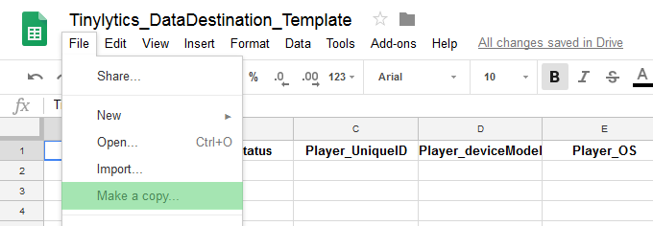

2. In your new copy, go to Extensions > AppsScript
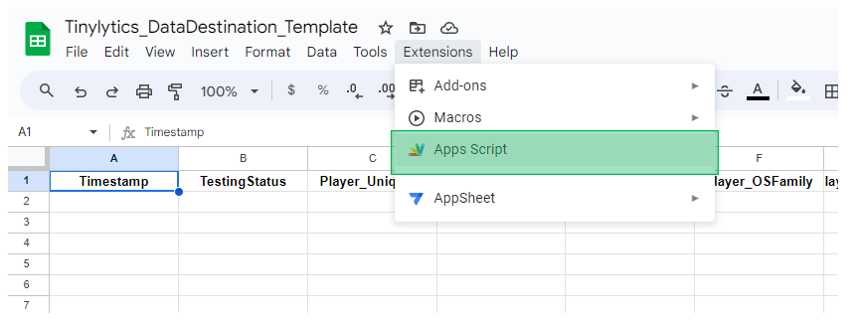
This will open a new tab, a project named Tinylytics_Instance, with a single script called PostGetHandling.gs

3. Go to Deploy > New Deployment…
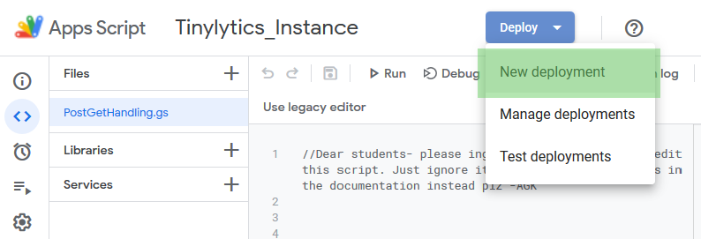

4. That will bring up a prompt like the following. Enter a quick description for what you’re using this for. Change “Who has Access” to “Anyone”.
Then click “Deploy”
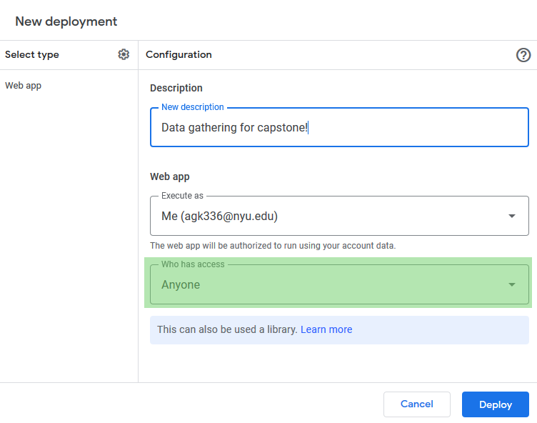

5. An Authorization Required prompt may appear. If so, click “Authorize Access” and then “Allow”
Note: This is only affecting the view/edit permissions for this particular workbook. No one else has access to your data.
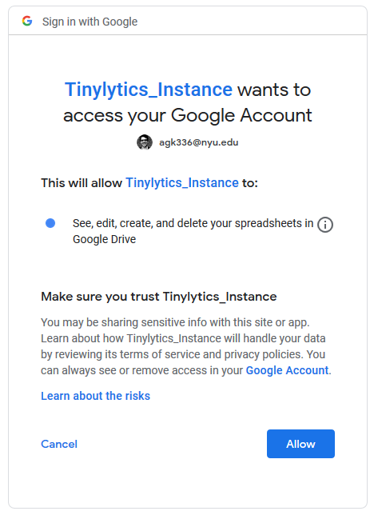

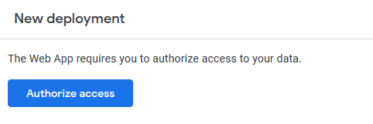

6. After a short delay, the project is displayed. Click “Done” to close the deployments window.

7. Click the dropdown at the top of the code editor, and select the “Setup” function. Then click “Run”.
If the authorization prompt didn’t appear earlier, it should now.
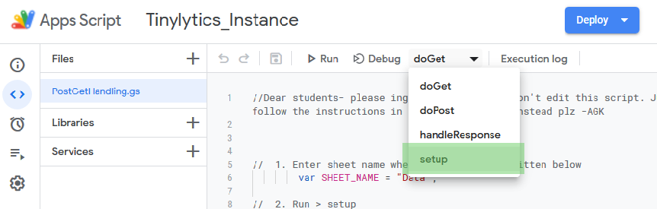

8. After running the setup function, navigate again to “Deploy”, and “Manage Deployments”.
We need the “Deployment ID”, it’s a long code of letters and numbers. Copy it.
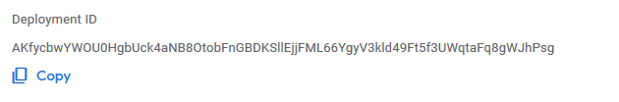
9. Back in Unity, click Windows > Tinylytics > Configure, to bring up the config window.
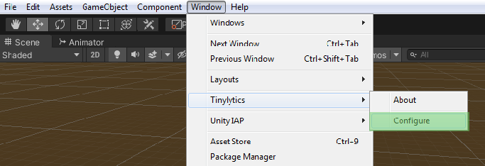
10. Click “Create New Config File”
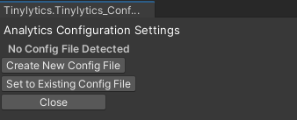
10. Paste the code from step 8 into the Deployment ID field. Close this window.
11. To check if it’s working, go to Assets / Tinylytics_AnalyticsTool / _DemoScene
Click on “ExampleScene” and hit play, wait a moment, and then exit play mode. Now go back to your data sheet. If you did everything correctly, you should see data populated!
How to Track Data
Option 1: Call using code
In any of your scripts, you can log a data event by calling Tinylytics.AnalyticsManager.LogCustomMetric. You need to supply the metric name, and the data, which must be formatted as a string (if it is a int or float etc, use the .ToString() method when passing the data).
In this manner, you can embed the analytics tracking directly into your gameplay scripts.
Caution: The game can only send so much data at once. Do not log data in the Update() loop!

Option 2: Customize the Analytics Manager
If you’re an advanced user, you can customize the analytics manager yourself. It’s located in Assets > Tinylytics_AlayticsTool > Backend, open AnalyticsManager.cs
You could write your own tracking commands here. “LogSessionPlaytime” is an example of how the manager could track playtime, and report it whenever called. In this way, you can extend Option 2 by consolidating your reporting code here.

Lastly to disable analytics:
Navigate to Assets/Tinylytics_AnalyticsTool/Resources/
Click on the Tinylytics_BackendManager prefab, and Uncheck “Analytics_Enabled”. If this is unchecked, no data will be sent.

